**Agenda:**

- Brief discussion on reporting tools and ACS strategy  
- Architecture of the Reporting Platform  
- Current applications support: Utility Data Model (UDM) vs Non-UDM  
- Very brief demo of the Historical Data Analysis Reports  
- Deep dive into reporting: End-to-end work-flow of creating and deploying an application for reporting and analysis

Architecture

**Report Designer** is an Integrated Development Environment (IDE) that enables report design and presentation of critical business data. It provides a toolset for designing an application and testing reports. Once report design is complete, the report is published to server for generation, delivery, and management.

**Report Server** is a Java report generation and management tool. It enables efficient management, sharing, scheduling, versioning, and delivery of reports. Report results can be saved to a versioning system, sent to enterprise/workgroup printers, or e-mailed.

**Page Report Studio and Web Report Studio** enable reports to be accessed through a web browser via Dynamic HTML, or AJAX. With Page Report Studio and Web Report Studio, reports can be modified using filter parameters, sort, and drill capabilities. Users can drag and drop columns to and from an existing report, dynamically change chart types, pivot crosstabs, add groups, convert report components or create an entirely new report. The results can be exported to the standards formats for use in desktop applications.

**Visual Analysis** is a WYSIWYG product to visualize the result of every work step. Simply by dragging and dropping data fields onto a layout module, users are able to visually create crosstabs and charts step by step. The use of colors, sizes, shapes, and pie slices provides rich visualization of the information.

**Dashboard** delivers information using a portal interface rather than a report. Users can freely choose the objects they want to display in the dashboard, without having to know how these objects were created, what data sources to use, what styles to set, and so on. A dashboard can hold multiple data components so that when browsing the dashboard users are able to see multiple data aspects. Filter widgets can be applied to one or all the components of a dashboard.

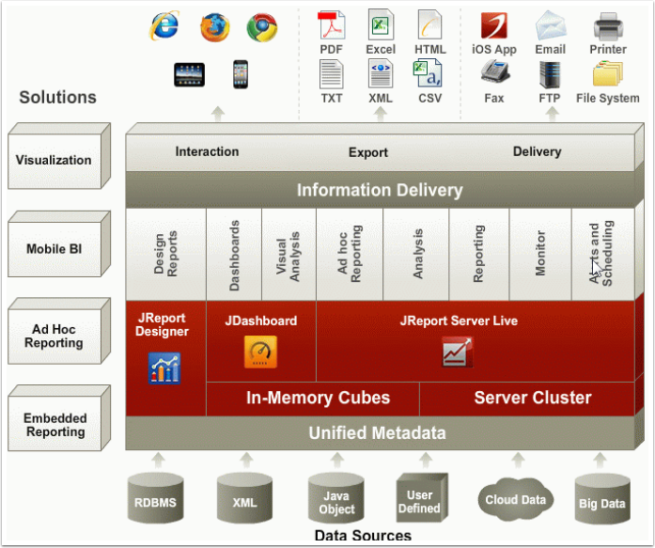

Utility Data Model (UDM) (PRISM Enterprise Portal)

The UDM is a type of information model that represents the distribution operations/management SCADA (DMS) system. Within the field of software engineering a model can be abstract or a formal representation of entity types (company, regions, substations and devices) that includes properties/attributes of these entities, relationships and the operations that can be performed on them. The entity types in the model are your real-world distribution asserts. Typically, this is used to model the DMS domain in a way that removes the complexity of the underlying database structures, allows you to model your operations and exposes a user-friendly interface for reporting and analysis to the user.

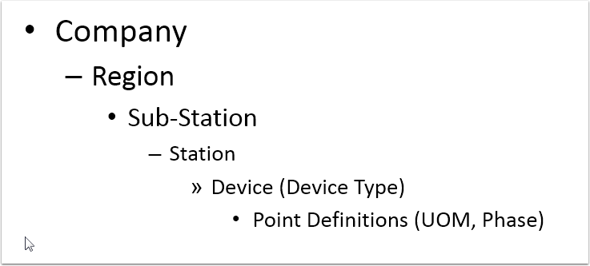

Non-UDM Model (PRISM Reporter)

This version of the model just has the following attribution

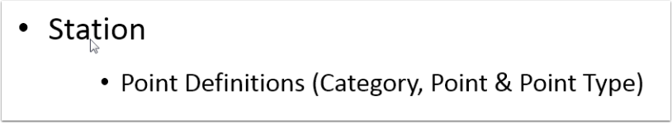

How is SCADA data archived for reporting?

1) genHDA process is configured for redundancy and auto-recovery

2) Forms are provided to update the model and historic data if needed

3) We can also update the model from SCADA automatically on a nightly basis.

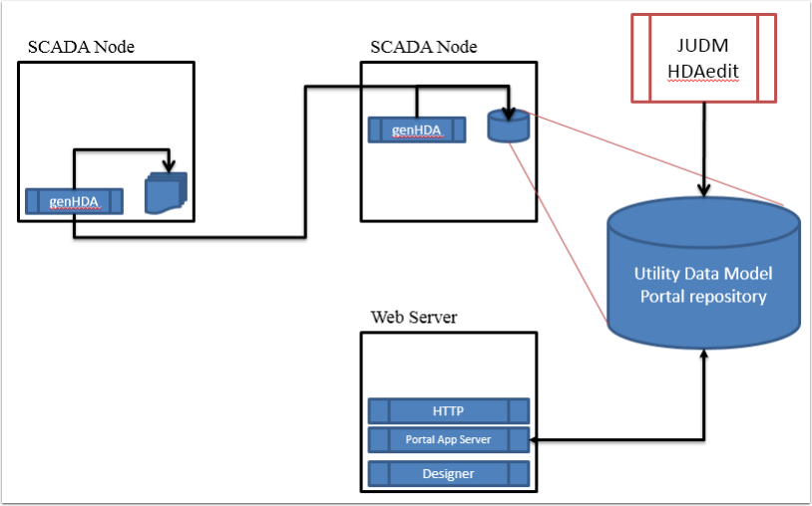

Report Design Workflow

Every task either simple or complex requires a defined process. Designing a report application is not different and will only help in making a better solution if it is well planned.

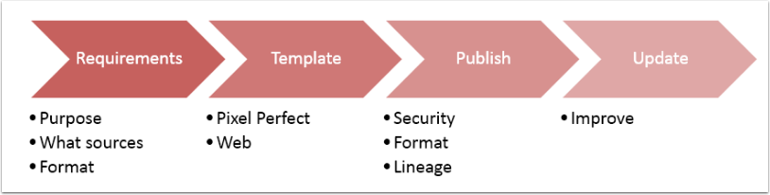

Requirements to start the process

1) Report Designer Software  
2) Report Server  
3) Access to data sources with all the credentials needed  
4) Report requirements

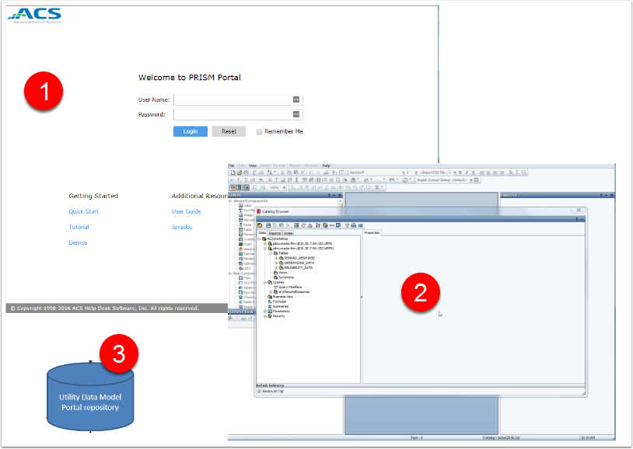

Application / Report Requirements - Deep Dive....

**Planning**

- Plan the report application  
- What are the domain specific problems you are trying to solve?  
- Gather the information necessary

**Real World Case**

Your department would like to analyze the industry's history of Demand Response initiatives. By some stroke of luck data was acquired from a government source and now you need to analyze this data for what its worth.  
  
To accomplish this task you have to create a new reporting application to not only use standard pre-built reports but also allow ad-hoc reporting, analysis and visualize the information in a browser.

Creating the Application Catalog

A catalog stores all of the object definitions that you have created while developing the application / reports. This includes data source definitions, component customizations, style definitions, and more.

Business views are a semantic layer - a view of the data source that you create for a business analyst to use to create analytic reports.

Parameters are used to control the report content at runtime. They are most often used for entering data selection criteria.

Formulas and summaries are objects that are computed at runtime.

The following illustration summarizes the content of a catalog file:

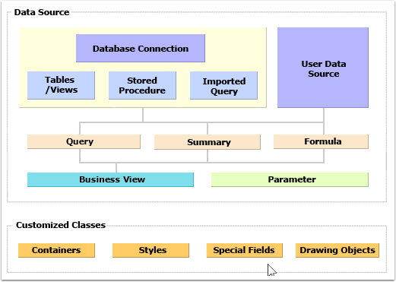

Catalog Infographic

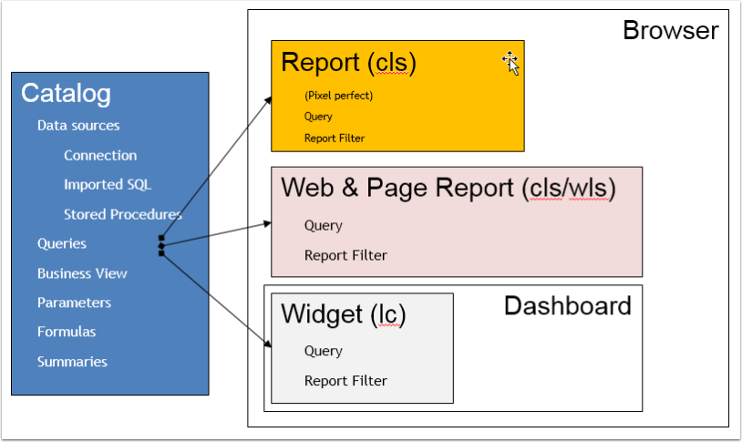

Business Intelligence Concepts

All BI tools operate on this premise of dimensions (features) and measures (facts). This allows for seamless aggregation, slice & dice and drill up or down.

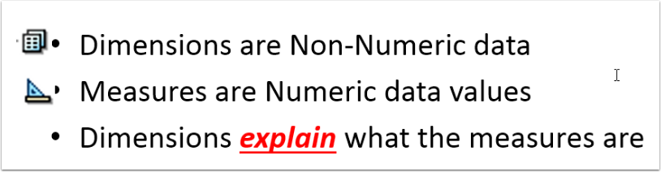

Creating the catalog

The Driver and URL will vary for different Databases - here we are using the Oracle Database

- Create a DataSource:

Driver: oracle.jdbc.driver.OracleDriver  
 URL: jdbc:oracle:thin:@10.30.7.96:1521:EMS  
 Must have the right credentials: username & password  
 Must have the networking infrastructure to support connections  
 Date Format: MM/dd/yyyy  
 DateTime Format: MM/dd/yyyy HH:mm:ss

- Name and Save the connection configuration

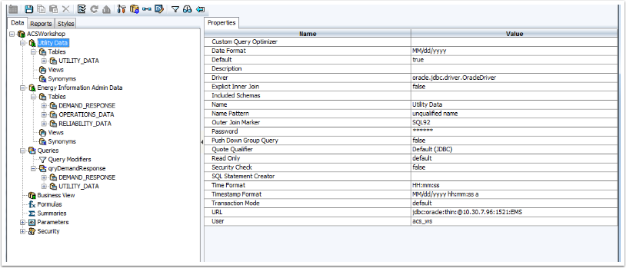

Adding Tables (Data)

- Right-Click the Tables node and select the desired tables

If the solution requires Views - then do the same to add Views to the catalog

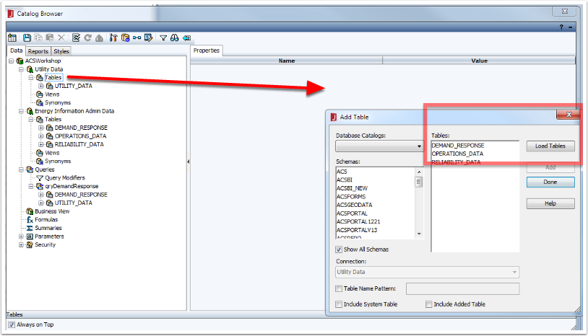

Adding Queries

- Right-Click the Queries Node

- Provide a meaningful Name for the query (Tip: use camelCase notation to make it readable; this eliminates the need for "_" and "-" to be used in the queries

- Add the tables or views necessary to provide the solution for the report requirements. In this case we are emulating different data sources.

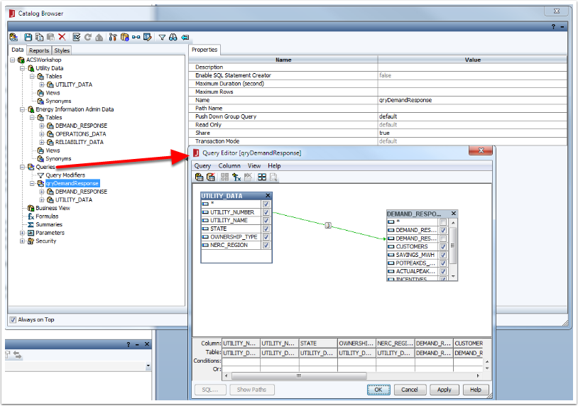

Adding Parameters

Create a simple parameter for NERC Region

1. Right-Click the Parameters Node - "Add Parameter"
2. Give it a meaningful Name
3. Set the Value to "Bind with Single Column"
4. Select the "NERC_Region" field from the Bind and Display columns (since there is no value/description fields we use the same field)
5. Click on the smart button ("...") to open the SQL Editor; we want to sort the displayed data, so add the " order by UTILITY_DATA.NERC_REGION"
6. Click "Check" to make sure the changes are valid
7. Click OK
8. Click OK again to complete the operation
9. Click the Save Icon

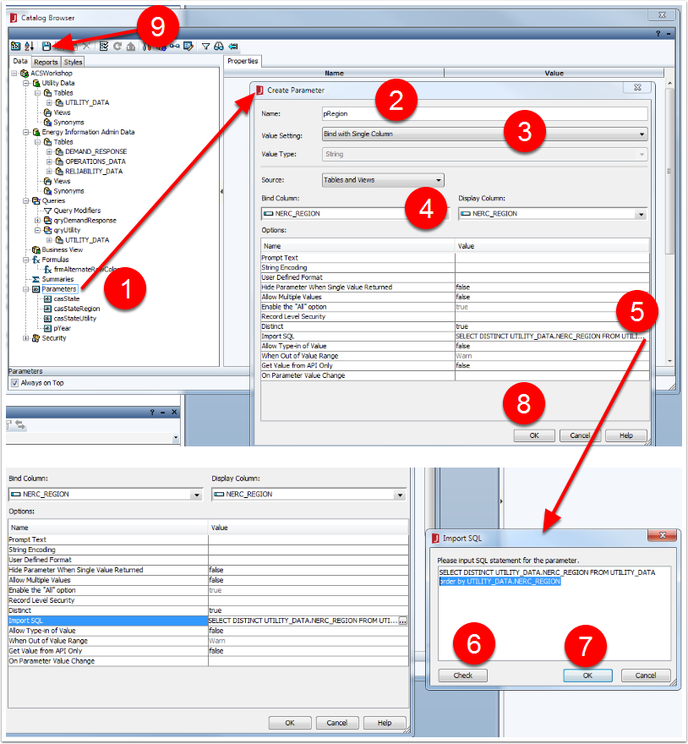

Notes about DateTime Parameters

Date time parameters are very important in queries - especially timeseries data. They need special attention because of the various formats that may have to be used to get the desired selection parameters.

LHS: DateTime Field in the Database  
RHS: Parameter needs to be in the same format. You must convert the parameter to support the format expected for the database platform

Example (Both data & parameter are of DateTime format)

LHS: DEMAND_RESPONSE_DATA_YEAR   
RHS: to_date(@pDateTime,'MM/dd/yyyy hh:mi:ss PM')

Example: Need to extract Date part only

LHS (Database field is DateTime) Convert it to CHAR format: to_char(DEMAND_RESPONSE_DATA_YEAR, 'mm/dd/yyyy')  
RHS (Parameter is DateTime): to_char( to_date(@pDateTime,'MM/dd/yyyy hh:mi:ss PM'), 'mm/dd/yyyy')

Example: Need to extract the Year part

LHS (Database field is DateTime) Convert it to CHAR format: to_char(DEMAND_RESPONSE_DATA_YEAR, 'yyyy')  
RHS (Parameter is String with MultiValue select): @lYear

Add the lYear (String with 2010-2015) & pYear as DateTime

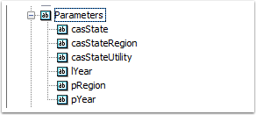

Adding Cascading Parameter Prompts

What this does is cascade the filter down to the last parameter. In order to use this feature ALL parameters MUST be used in the Report Query Filter.

The first parameter will be displayed: User selects a "Single" State

The State is used to filter the NERC Regions for the state and is displayed: User selects a "Single" NERC Region

The NERC Region is used to filter the Utilities are displayed: User can now select "Muliple" utilities to report on

The allow "Multiple" values setting determines what operator can be used in the query.

Allow Multiple Values = false (Query filter Operator Must be "=")  
Allow Multiple Values = true (Query filter Operator Must be "in")

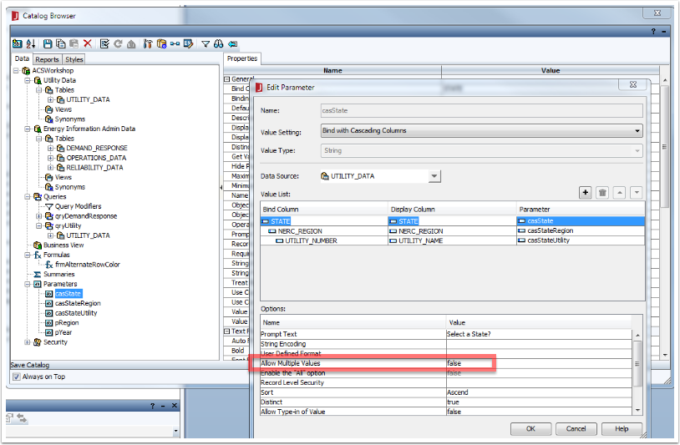

Adding Formulas

ADD: Alternate Rows Colors

String q="";  
global Boolean ee =true ;  
if(ee==true)  
{  
 ee=false;  
 q="0xdde9f2";  
}  
else  
{  
 ee=true;  
 q="0xffffff";  
}

ADD: Report Footer Text

ToText(CurrentDate()) + ' ' + Now() + ' : ACS (C) Copyright ' + ToText(Year(),'####')

Date Time Formulas

**ADD: frmYear**  
ToText(year(@FieldName))

**(For Reference) Quarter**  
"Qtr"+Quarter(@FieldName,1)  
ToText(year(@FieldName)) + "-" + Quarter(@FieldName,1)  
 **(For Reference) Month**  
ToText(month(@DateField),"00") + "-" + MonthName(month(@DateField))  
ToText(year(@DateField)) + "-" + ToText(month(@DateField),"00")  
ToText(year(@DateField),"0000") + "-" + ToText(month(@DateField),"00")  
  
**(For Reference) Day**  
ToText(month(@DateField),"00") + "/" + ToText(day(@DateField),"00") + "/" +ToText(year(@DateField),"0000")

ADD: constEnergyCost: 30 (Assumed energy price/MWh)

ADD: Derived Formula: frmActualSavings

1. Add the data field
2. Add the operator
3. Add the other operand (data field, formula or constant)
4. Save the formula

Save the catalog

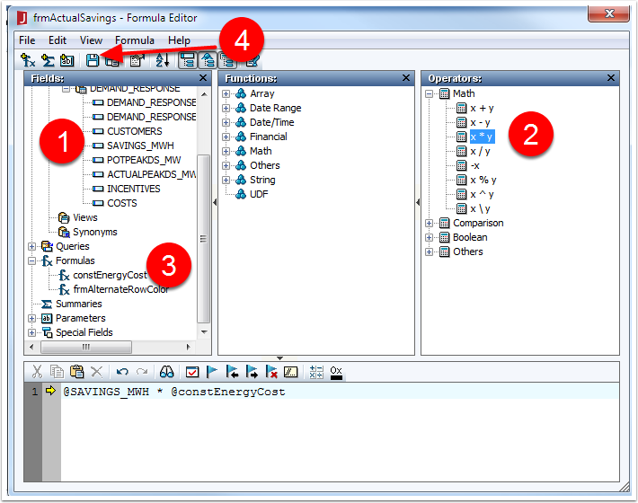

Generic Report Creation WorkFlow

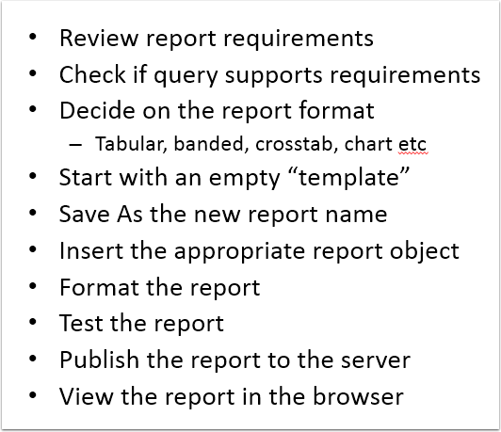

Adding Query Filters (These are the parameters that act as conditions for the query)

1. From the Query Menu -> Select Filter
2. Add Condition
3. For each condition add the
4. @DEMAND_RESPONSE_DATA_YEAR = to_date(@pYear,'mm/dd/yyyy hh:mi:ss AM')
5. @STATE = @casState
6. @NERC_REGION = @casStateRegion
7. @UTILITY_NUMBER in @casStateUtility

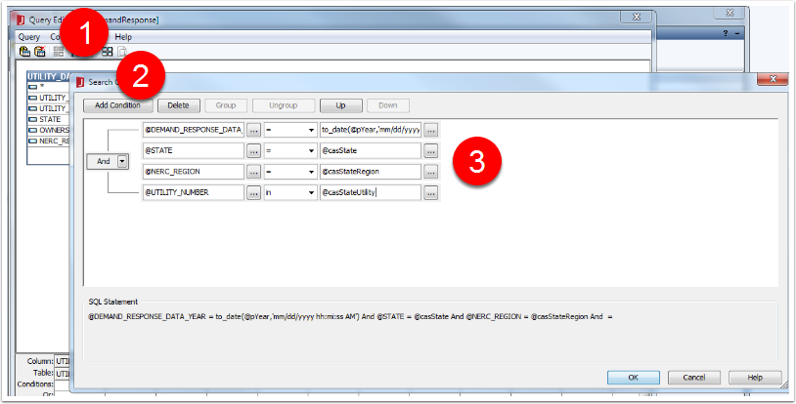

Adding Summaries to the report

For reference purposes we will just add a summary for Count - there are other more effective ways to create summaries

1. Right-Click and Add Summary
2. Select the desired aggregate function
3. Select the field to use summarize on
4. Select Dynamic Summary if this is to be used in a Banded Report
5. Click OK
6. Name the summary & Click OK

Save the Catalog

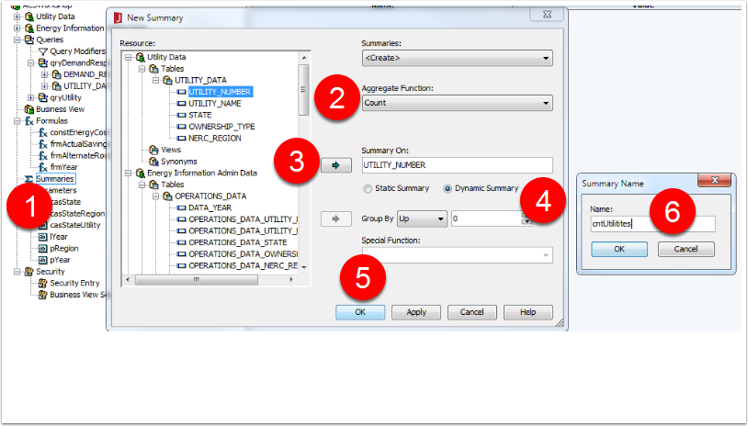

Create the Report

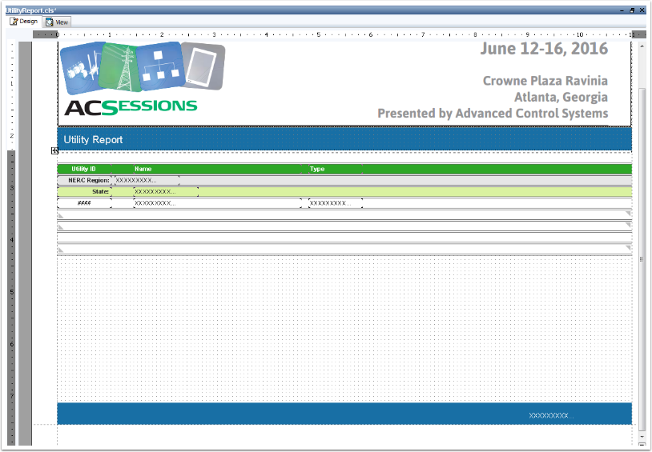

Testing the report in Designer

Click the View Tab to view the results

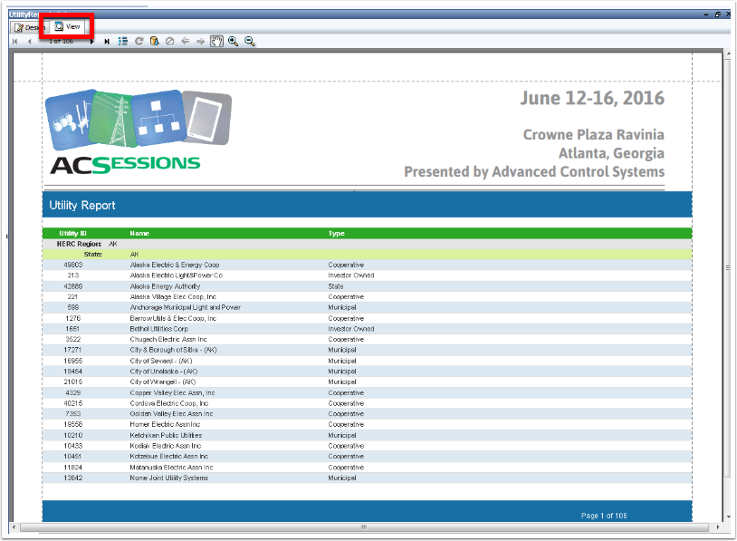

Publishing

In order for users to access the reports the creator must publish the catalog and report(s) to the Live Server

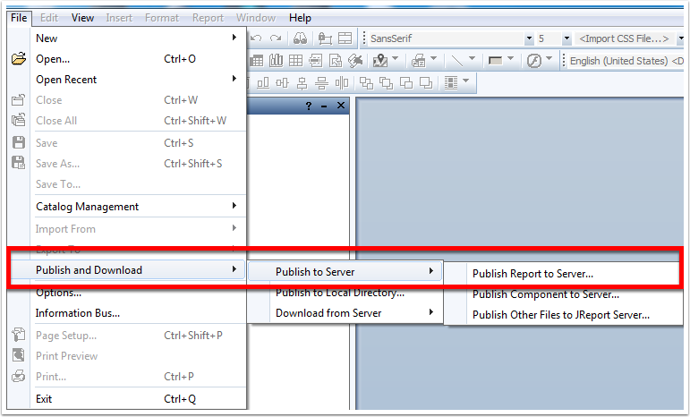

Connect to the Server

Enter the information of the server:

Host Name or IP  
Port: 80  
Servelet Path: /ACSPortalV13/jserver (This will be different for the deployed environments)  
User Name & Password: This user must have Publishing privileges

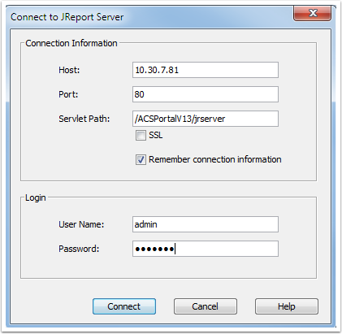

Select Publishing options

1. Select the catalog & reports that have been added or changed
2. Click Browse to change the Target Resource Folder
3. Select the location where users will access them
4. Click OK
5. Click OK
6. Click Cancel (if there are no other resources that need to be published)

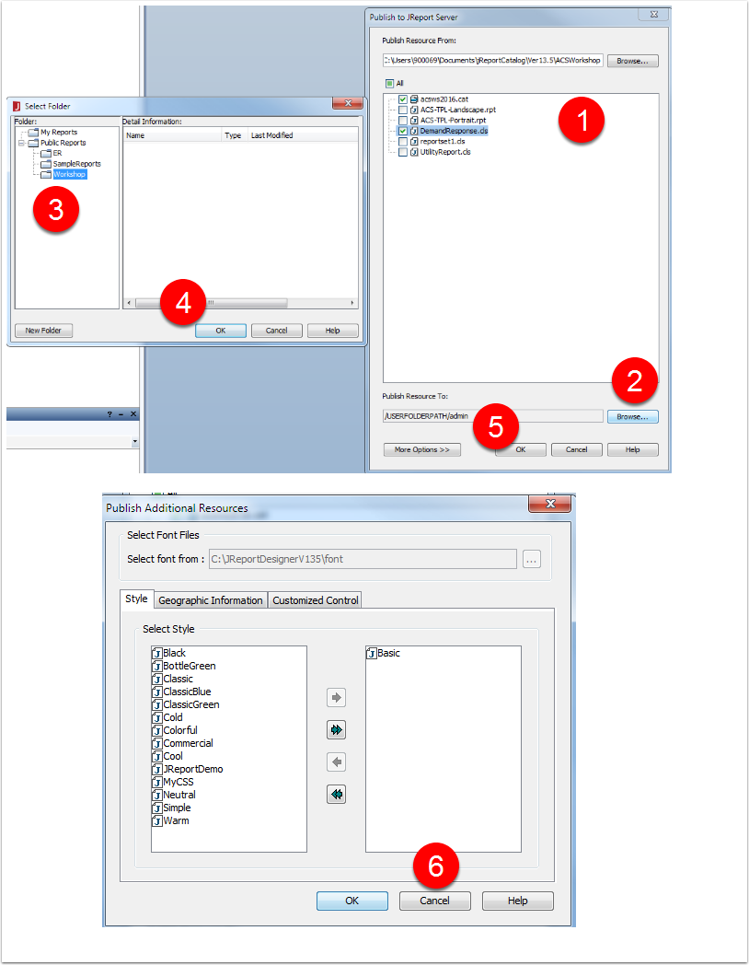

Log in to the Server via a browser

http://<site>/ACSPortalV13

Navigate to the Resource Folder

Click on the Report

Select/Enter the parameters

Click OK

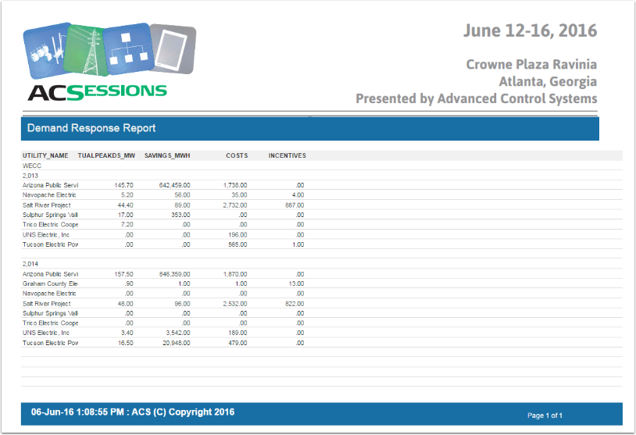

Creating a Business View - from existing Query

Why do you need to do this?

Business views shield report end users from having to understand physical structure, and enable easy building of complex reports containing multiple components. Business views enable end users to build reports and analyze data based on a set of view elements that they can easily understand. This allow a user to generate ad-hoc reports based on their individual needs.

1. R-Click and Add Business View
2. Give it a name
3. Optional: Set Restrictions on Time and Row Limits
4. Select Queries
5. Click on the Arrows to make selections
6. Click OK

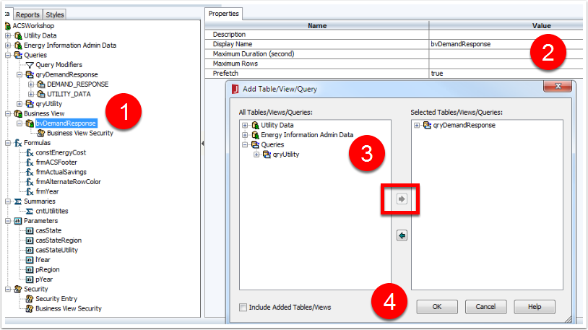

Build the View - Typical steps

1. Select the field
2. Drag & Drop in Right Panel (By default they are Dimensions - this is IMPORTANT to understand)
3. Change the Display Name
4. Click OK

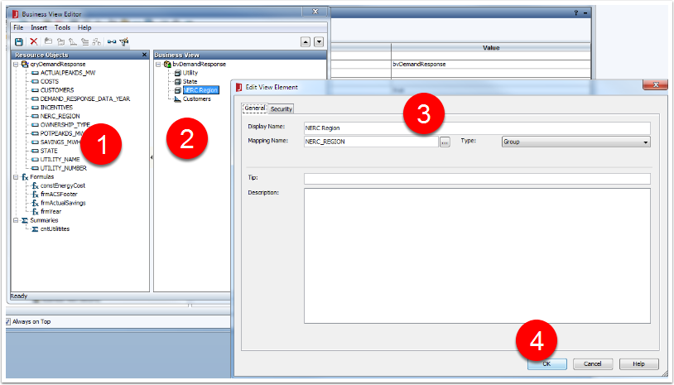

Create a Measure: This is an important object in analytics

1. Select the root node of the Business View
2. Click on the Measure Icon (this will only be enabled after Step 1)
3. Select the Numeric Field (Statistical aggregations will not work on Dimensional (non-numeric) data
4. Give the Measure a name
5. Select the Aggregate function
6. Click OK

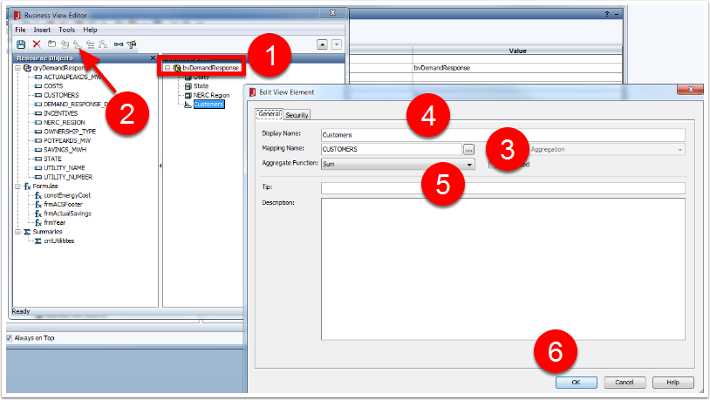

Completed Business View

Save the BV and Catalog

Publish the Catalog

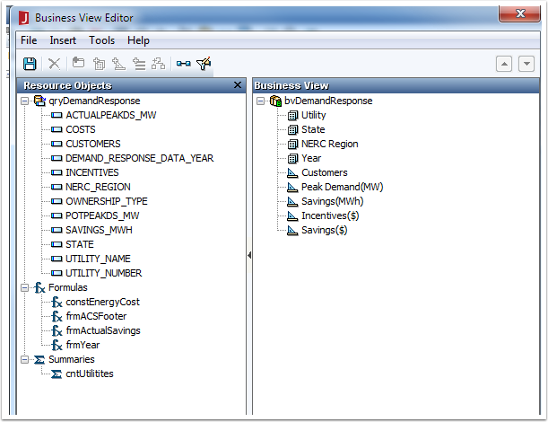

Test the Business View in the browser (Design a Web Report in Browser)

Navigate to the Resource Folder where the catalog was published

Select New -> Web Report

Give the report a Title

Click Next

Select a Layout

Select a Component from the list - Crosstab

Click Next

Select a Data Source

Add Dimensions to Rows & Columns (select and click the appropriate arrow to place the dimension in the rows or columns list)

Add appropriate Measures to the Summaries (Do the same - if using multiple measures you can label them)

Click Next

Save the Report in the appropriate resource folder

Click the Report link

Select the parameters

Click Submit to view the report

The report opens in View Mode; if you want to Edit the Report:

Select the "Edit Mode" selector at the top right

The report is available to editing

To change properties of any report element

Select the Menu -> View -> Inspector to show the Properties panel (Right side)

Select a report object in the main panel

All editable properties are now available to modify

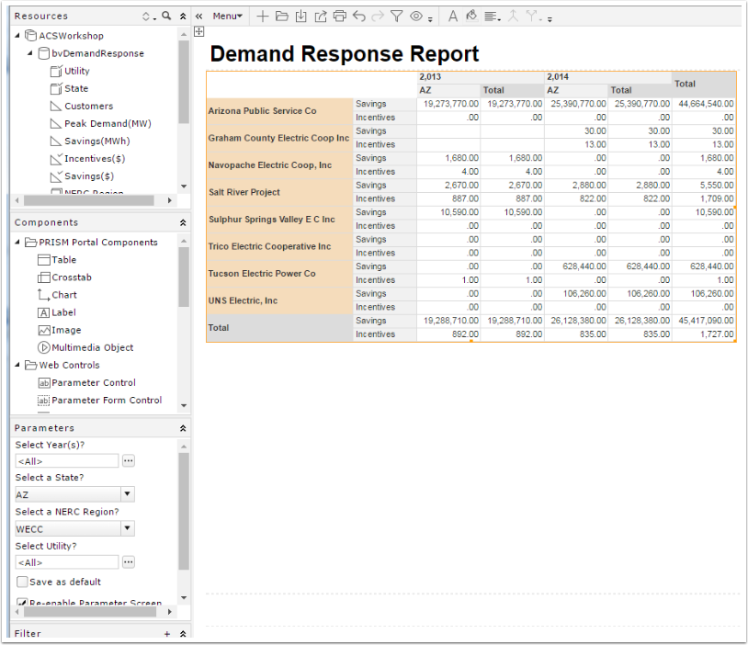

Creating More Queries - Tips

Check requirements and look to reuse queries

Add Parameters variations if needed

Copy, Paste and Rename Queries

Edit the query and change the Filters

Create the new Business View

Publish & Use it

***Task: We want to have an unrestricted BV for Demand Response that allows us more flexibility for Visual Analysis. We will remove ALL the filters. This of course should not be the case when the database it very large; however; we can still restrict the time and rows at the BV Level!***

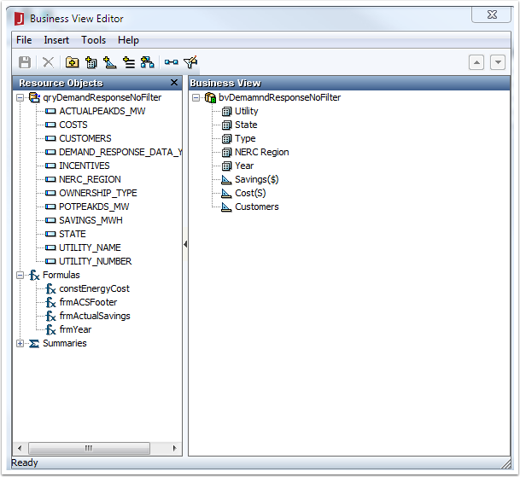

Create a Dashboard Widgets - Bar, Bubble & Crosstab Chart

Library components are used by end users to build dashboards. A library component can contain multiple data components and uses .lc as the file suffix. The data sources that can be used to create library components are business views (BV) that are resources built on top of queries, imported SQLs, stored procedures and all other data sources.

Each library component can be equipped with a configuration panel which is used to specify parameter values for the library component, filter or sort on the library component, or change properties of the library component.

**Create a Bar Chart LC: DemandResponse-BarChart**

File -> New -> Library Component -> Chart -> OK

Select the bvDemandResponseNoFilter Data Source -> Next

Single Chart Option : Bar, SubType: Clustered Bar 2-D, Next

Category: Year, Series: NERC Region, Values: Savings

Click Finish

Change the Wrapper Title in the Inspector: Savings By NERC Region

Note: For Auto Refreshing options: Set the Interval and Enable Auto Refresh

**Create a Bubble Chart LC: DemandResponse**

File -> New -> Library Component -> Chart -> OK

Select the bvDemandResponseNoFilter Data Source -> Next

Category: NERC Region; Series: Type; Values: X=Savings; Y=Cost; Radius: Customers

Enable Motion Bar for Playable Chart; Add Year

Finish

Change the Wrapper Title in the Inspector: Savings By NERC Region& Type, Sized by # of Customers

**Formatting a Chart:**

Right_Click on the Chart to access the chart element properties

Axes: Format - Set the label display options

The Properties Inspector allows for precise settings if needed

**Create another Library Component: DemandResponse-Crosstab**

Column: Year; Rows: Utility; Summaries: Savings

Change the Wrapper Title in the Inspector: Savings by Utility

Formatting: Rows: Auto-Fit; Column: Year Format

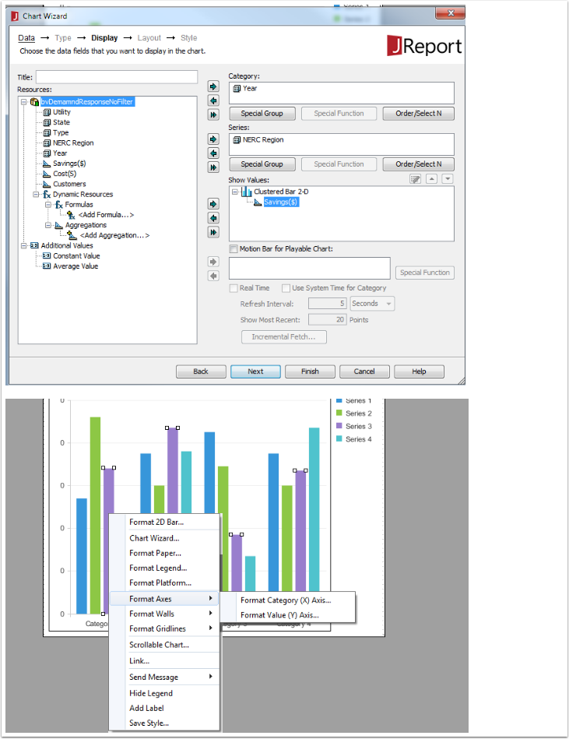

Publish the widgets

Save & Publish the catalog and chart

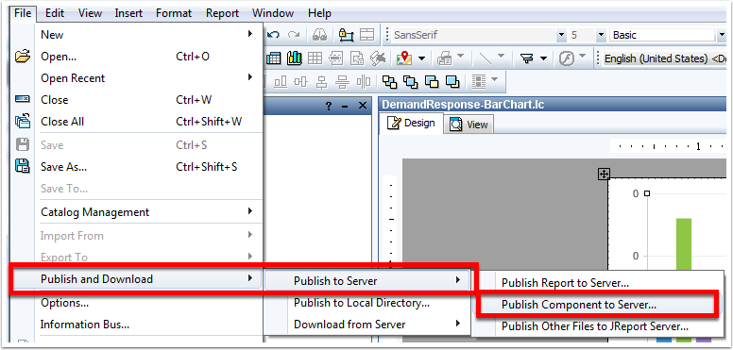

Create a Dashboard

New -> Dashboard

Click the "Show Resources" icon in the top left of the screen to slide out the panel

Drag & Drop Widgets and place them to your liking

Add a Filter Control for "State" to drive all the other widgets

Save the Dashboard

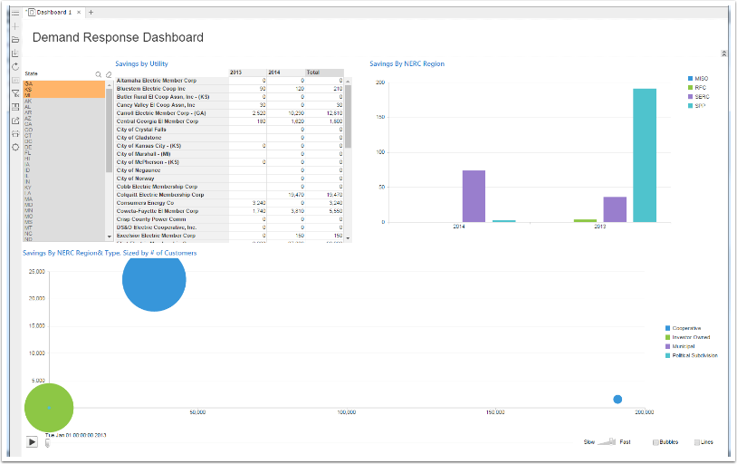

Schedule a report to versioning system (email, ftp, printer are options)

**Steps to schedule a report:**

Navigate to the report you wish to schedule in the Resources folder

Click on the "Schedule" Icon - the icons will only be shown when you hover your mouse over a report Name

Give the schedule report a name -> Next

Enter any/all parameters that are required -> Next

Select the Destination Type: Version, Disk, E-Mail, Printer, Fax or FTP - For this demo we select Version Tab

Enable "Publish to Versioning System"; Select Excel -> Next

Note: You can Apply Archive Policy: Specify the # of Versions you need to keep and also Auto Delete after x days or date

Conditions: Time Type: "Run this task periodically"; Set the desired Options -> Next

Notifications can be set if desired

Click Finish to submit the task

**Viewing Tasks**

Select the "My Tasks" in the header bar

Scheduled Tab: Active list of schedules as seen in (1)

Note the various option icons that are available: Run, Properties, Copy, Delete, Enable, Disable

Running Tab: Any report schedules that are running at the moment

Completed Tab: Tasks that have been Completed

Background Tab: Any reports that are running in background

**Accessing Versions:**

Navigate to the report that was scheduled in the Resources folder

Click on the "Versions" icon

The report versions will be listed as shown in (2)

Click on the Result to view/download the report / data

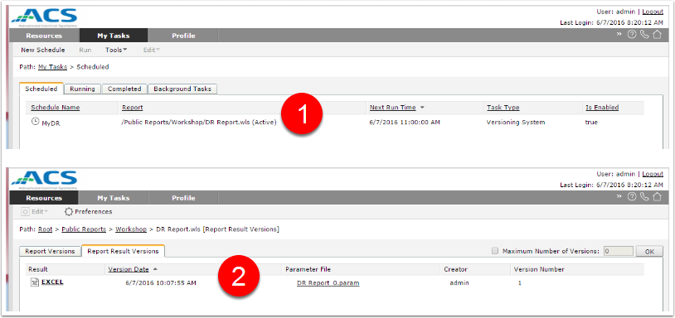

Server Administration Workflow

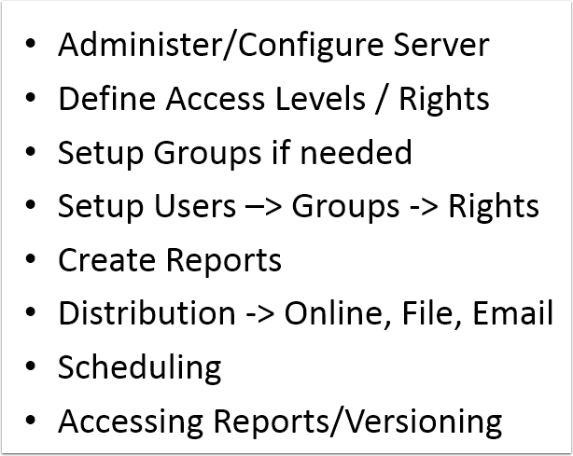

Create a Group & User

1. Create a Group
2. Create a User
3. View the User List
4. Assign a User to a Group

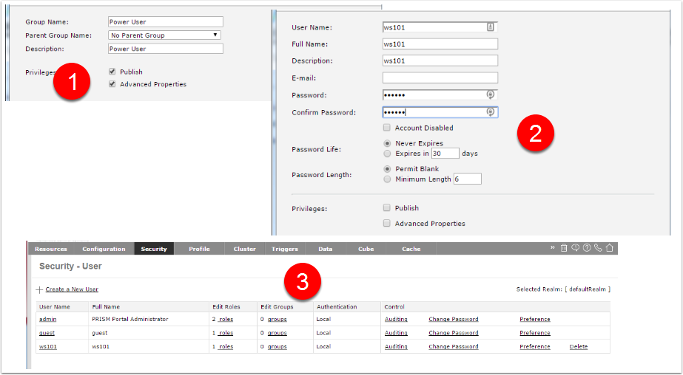

Assign Permissions to resources

1. Assign Admin Role to Users
2. Assign Permissions (User or Group) to Resources
3. Select the Resource (Public Report in this case)
4. Click Properties
5. Select the Permissions Tab
6. Enable Setting Permissions if it is not enabled
7. Select Group Options (if this is the intent - otherwise User)
8. Select the Group
9. Set the desired Permissions
10. Click OK

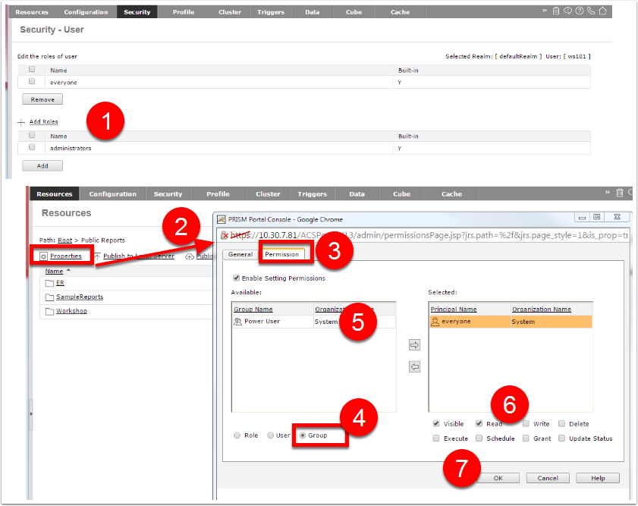

Configure a Business View for Analysis

Cubes can be scheduled to refresh on a daily basis and work the same way as a scheduled report.

Create a New Cube based on a Business View

Allocate Memory and Cache size

Schedule it to refresh

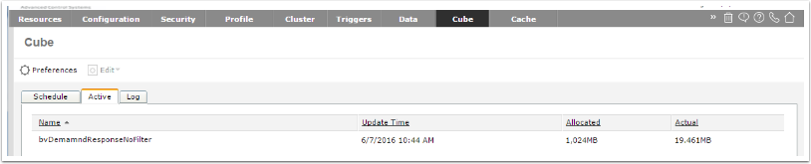

Visualization with the Cube

Navigate to the Resource where the Business View is located

Select New - > Analysis

Select the Business View

Drag & Drop dimensions and Measures to Visually Analyze the data

Add Filters if needed

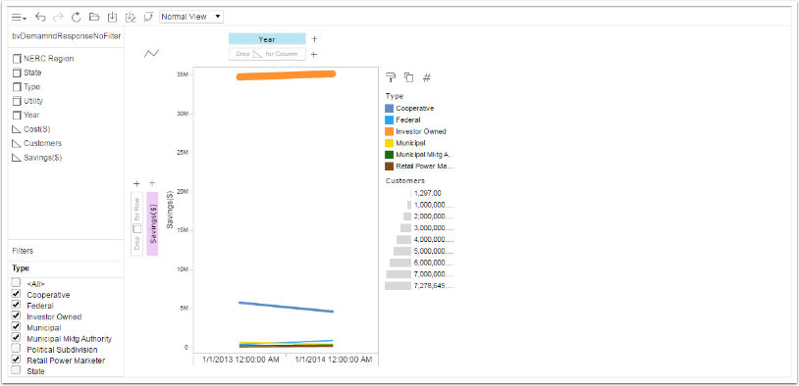

Q & A